Get and decrypt Db Password from properties Mulesoft application file.

Anypoint must have the security packages installed *Encryption module* and Mule *Studio Properties File Editor.*

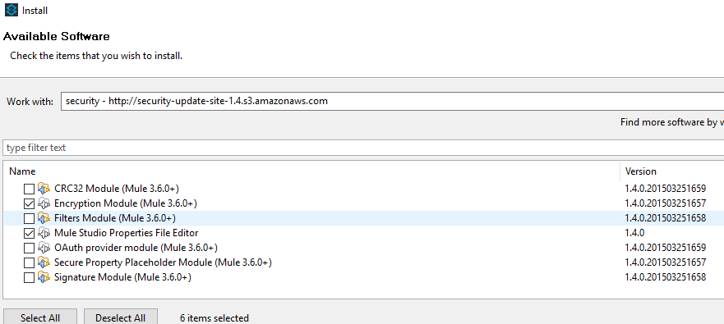

Properties file, right click and open with the Mule Properties Editor (only available if security packages are installed, these are not installed in Anypoint studio by default, see *above*).

NB: *There are separate application properties files for Sandbox and production, please ensure you have selected the correct one for the desired environment*

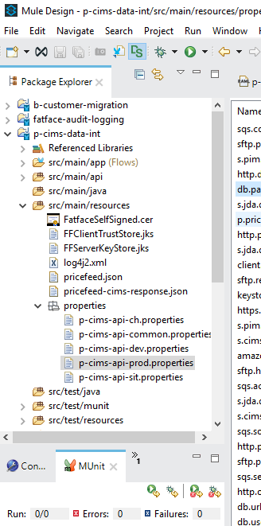

Once opened using the *Mule Properties Editor,* user name and password etc can be located.

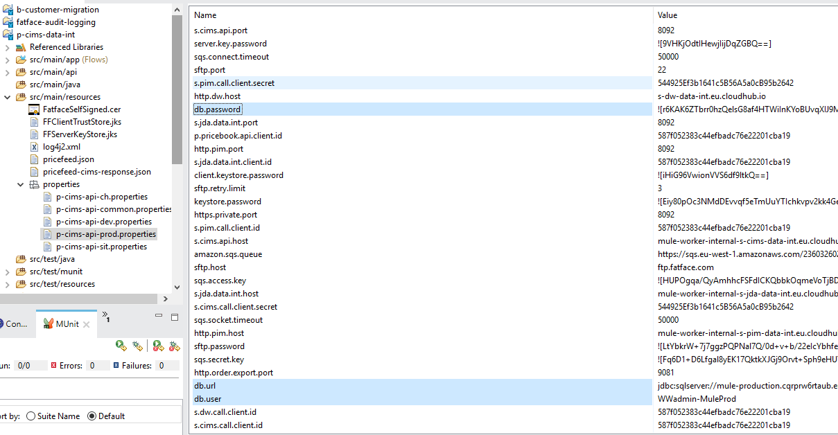

By double clicking on the ‘Name’ field of the db.password entry the following screen in displayed.

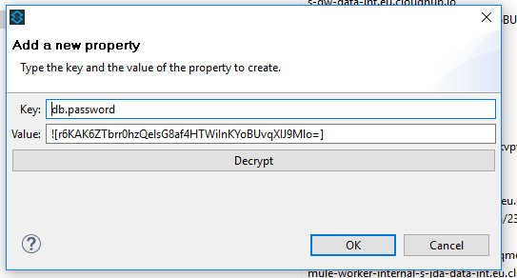

Enter the encryption key in the key field (the value: field is already populated with the encrypted password) for the relevant environment provided in the Fat Face confluence IHUB project Support handover document references section. Click the Decrypt button.

On the following screen select AES as your decryption algorithm and enter the encryption key

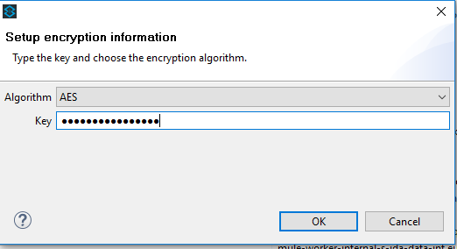

Click OK and the following screen should display the key and decrypted password that you can now use in combined with unencrypted credentials (user name etc.) from the properties file for application login.

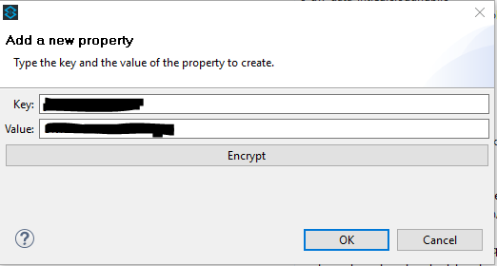

## fault finding from Mulesoft / Anypoint platform alerts

[no-reply@mulesoft.com](mailto:no-reply@mulesoft.com) Email Alerts.  
From 08:00 - 17:00 ‘Offshore’ support staff will currently investigate / triage by manually running SQL queries against the Audit_t table in the AWS RDS. Using the message ID, request ID the time They will then provide an analysis and a ticket will be raised in JIRA. All in going and outgoing requests are archived for Audit in this table. Offshore will eventually be able to determine priority;

e.g. P1 for next day delivery order (customer impact) or higher for 5-day delivery etc.

mule-production.cqrprw6rtaub.eu-west-1.rds.amazonaws.com,1433

Useful Queries have been created by Wishworks and are documented in the FatFace_IntegrationHUB_Phase1_SupportHandover document.

**AWS RDS Audit - Production environment.**

User: WWadmin-MuleProd

Pwd: See process above

DB: MULE_DB  
Table: Audit_t table

**Reporting Database - production**

User: MSIHub   
Pwd: See process above using same production encryption key

Server: DBPROD001

DB: Demandware

# Anypoint Platform – Monitoring.

View Alerts

1. Login to Anypoint Platform
2. Navigate to Management Centre
3. Navigate to Runtime Manager
4. Select Environment.
5. Select Alerts

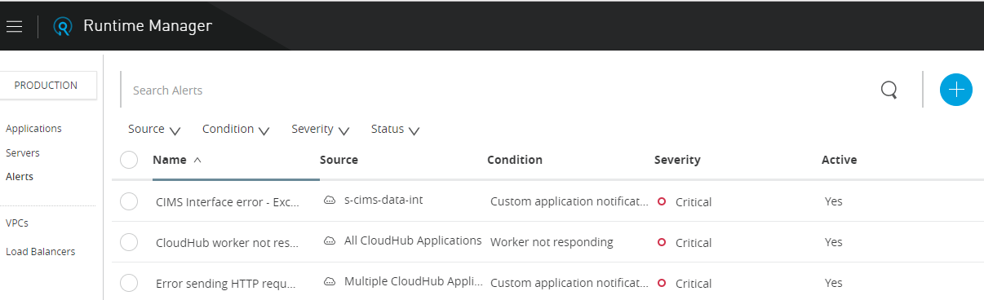

Select an Alert to view which applications can raise the alert and which Anypoint platform user receives emails when this alert is raised. The email message can also be amended here.

View Application Logs

1. Login to Anypoint Platform
2. Navigate to Management Centre
3. Navigate to Runtime Manager
4. Select Environment.
5. Select application.
6. Select logs.

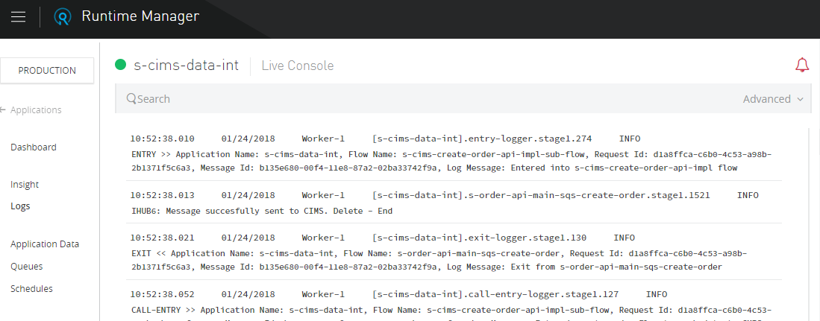

# Raise a support ticked with Mulesoft Support.

A registered user (AD) can Login to Anypoint platform using the single sign in URL.

<https://anypoint.mulesoft.com/accounts/login/fatface>

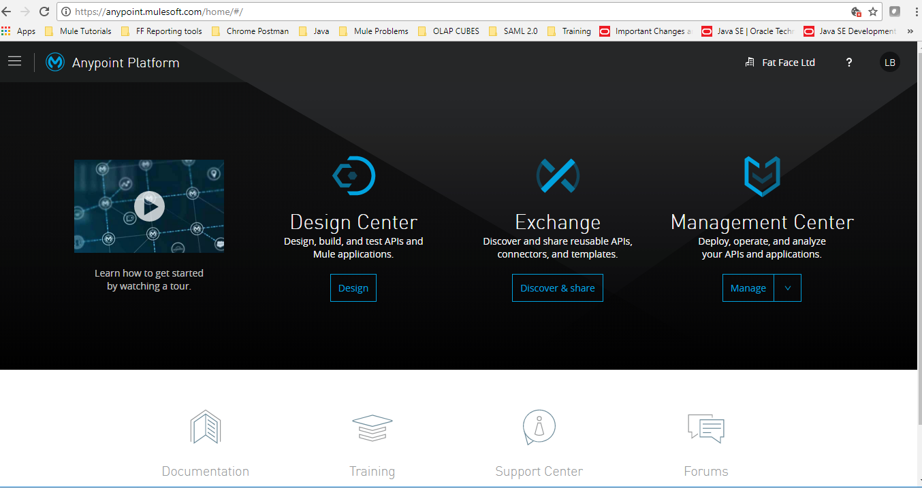

Click on Support centre.

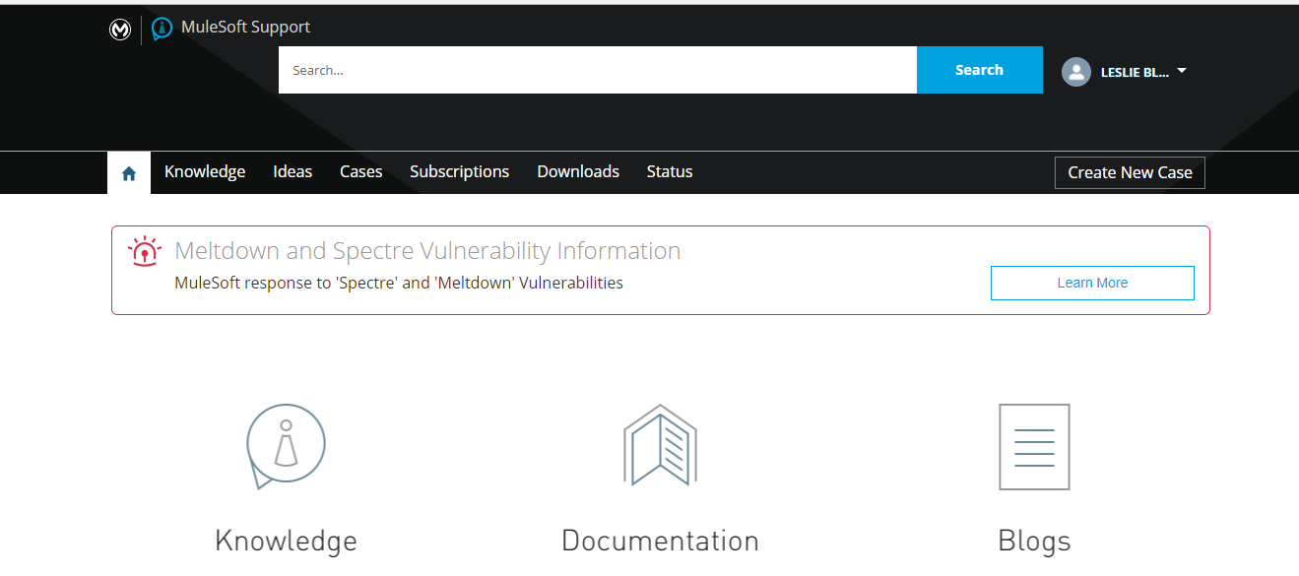  
You should be logged in, but might have to click login through Anypoint.

Click Create new case, fill in form and submit.